R. Reports Menu: 2. Permit Forms

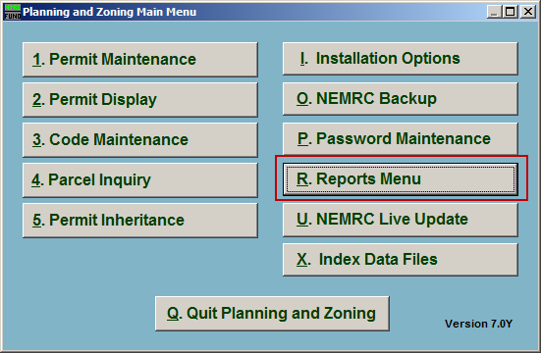
Click on “R. Reports Menu” from the Main Menu and the following window will appear:

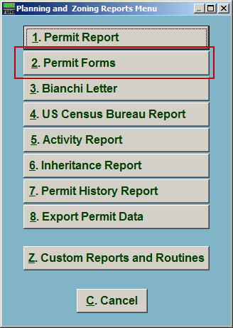
Click on “2. Permit Forms” from the Reports Menu and the following window will appear:

Permit Forms

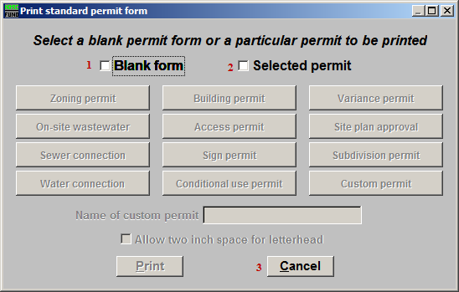
- Blank form: Click to select this option to print a blank Permit Form.

- Selected permit: Click to select this option to print a predefined Permit Form.

- Cancel: Click “Cancel” to cancel and return to the Reports Menu.

Blank Permit Form

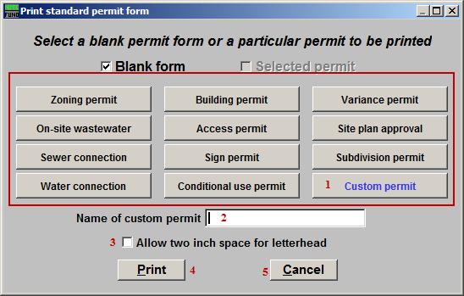
- The button that appears in blue is the selected Permit type.

- Name of custom permit: If you selected “Custom Permit” from item 1, then this field becomes available. Enter the name for this Custom Permit.

- Allow two inch space for letterhead: Click to check this box to have two inches of space at the top of the Permit.

- Print: Click this button to print. Refer to GENERAL PRINTING for more information.

- Cancel: Click “Cancel” to cancel and return to the previous screen.

Selected Permit Form

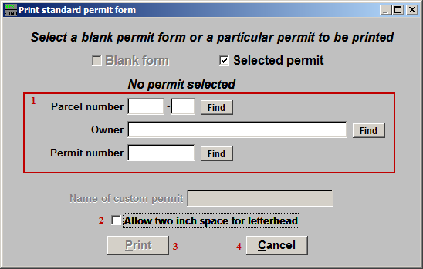
- Select the permit to be printed via one of the following methods:
Parcel number – enter the parcel number or click the find button to look up by parcel number.
Owner – enter the owners name or part of the name and click the find button to select a permit.
Permit number – type in the permit number or click the find button to look up by permit number.

- Allow two inch space for letterhead: Click to check this box to have two inches of space at the top of the Permit.

- Print: Click this button to print. Refer to GENERAL PRINTING for more information.

- Cancel: Click “Cancel” to cancel and return to the previous screen.

